ReserveMe Hotel reservation mobile application

E.M.S.Lakmal
Department of Computer Science and Engineering
Moratuwa, Sri Lanka
sarangaekanayaka.13@cse.mrt.ac.lk

Abstract—Travelers of Sri Lanka spent considerable time of their journey for find accusations. Main objective of the “ReserveMe” is help them to reserve best accommodation quickly and easily. And help Sri Lankan hotel owners to promote their hotel and increases their business. There are two kind of users in “ReserveMe” as hotel owners and customers. Hotel owners can register their hotel in the system. Hotel customers can make reservation through the system.
Java was used as the programming language with Android Studio 1.4 as the IDE for the Android platform. Data base was implemented in 000webhost free sever. Image icon for the application are created using Adobe Illustrator CS6.

Keywords—Android, Android Studio, Genimotion, Smart Phone, Virtual devices

Introduction
Both local and foreign travelers face difficult situations when finding an accommodation in rural areas of Sri Lanka with required facilities and suitable amount. They spent considerable time of their journey for find accusations. Even they find accommodations in a normal way, there may be some negative facts like accommodation can be full, not quality enough, Prices can be not good enough for the service, May difficult to reach that place etc. Also owners spend about 20% of their profit for third party intermediaries. Some hotels located far away from the town joiners even don’t know about such places. So that hotels have less business.
Using “ReserveMe” travelers can find accommodations just typing destination. Before make a reservation they can check ratings of each hotel, room availabilities and prices. Since they have lot of choices, can select the best accommodation considering above facts. Via this system they can avoid the problems and spend much time in their journey rather than finding accommodations. Hotel owners can register their hotel in “ReserveMe” promote it and can manage their room charges, facilities and provide some special offers by looking at bookings. Since this is a direct booking hotel cane save commission fee charged by third party intermediaries.
Paper structure is as follows. Section 2 describes the related literature of the hotel reservation applications, section 3 describes the system requirements and system design, section 4 explains the system implementation, section 5 summarizes the testing and analysis details of system, section 6 is conclusions and future work and finally are the references.

literature review
There are many web and mobile applications available for hotel reservation. But they only provide room availability, capacity and prices details of a particular hotel. And they are not even well updated. Users can’t view the locations of rooms before make a booking. So, since this is an online booking even same family may have rooms of deferent floors. As a solution for this I hope to provide graphical user interface which provide rooms map of hotel. Via this user will get know which rooms are booked and which are available. User can select rooms as his preference. And also via goggle map people can search hotels and read their details but they cannot make reservation via it. And also it shows only famous hotel and hotel in urban areas only. But main targeted users of “ReserveMe” are hotels in rural areas of Sri Lanka like Kataragama, Anuradapura, Polinnaruwa etc.

system models

System Requirements
Main functional requirements of “ReserveMe” are describe their. To ensure that the security of the system and for take initial details of each user each user system should allow to users to create a new user account. Before make a reservation customer should able to view details about the hotels. After make a reservation customer should able to rate the service of the hotel they take service. When make a reservation system should recode all the details about the booking and after customer confirm a booking, system should automatically marks relevant rooms as reserved. After customer leave the hotel system should automatically marks relevant rooms as available. Hotel owners should able to upload photos of their hotel, display some special offers and mark manual reservation requirements of the system can be mainly described by two parts.
Usability, supportability, Reliability, performance and security are the major non-functional requirements. With the lack of technological knowledge of hotel owners in rural areas they may require a training for get use to this system. “ReserveMe” should support for devices with less performances. System should able to repair with less time. User logging system will ensure the security and privacy of the system “ReserveMe”. Since there are no complex calculation inside processes, system might get much more time for one transition.

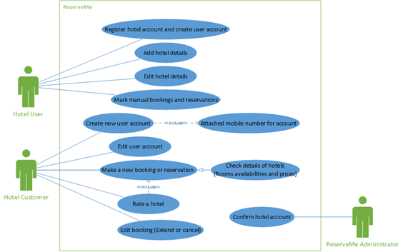
Fig. 1 : User case diagram of the system
There are three kinds of users in “ReserveMe” as hotel customer, hotel owner and system administrator. Hotel owners can register and create hotel account, add and edit hotel details and make manual reservations. Hotel customer can create and edit account, make new booking, rate hotels, edit bookings. While making reservation they can check details of the hotel. For rate hotel he must have to make reservation for particular hotel so there is a include relation between make new reservation and rate hotel user cases.

System Design
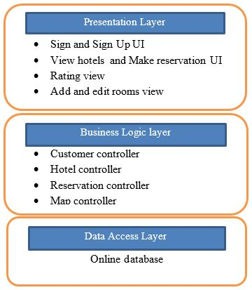
Main architecture sued is three layered architecture. Presentation layer provides the functionality required by using the application by user. All the graphical interfaces are relate to that layer. The business logical layer is used to decouple the user from the data storage and thus achieving security and privacy of data. The data access layer provides the data related functionality and methods of retrieving the data from data storage.
Fig. 2: Architecture diagram of the system
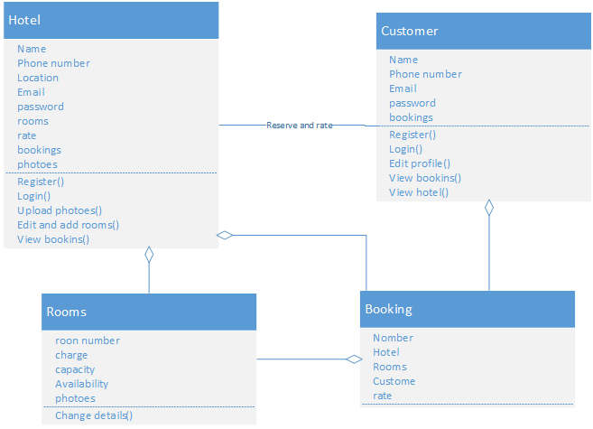
Fig. 3: Class diagram of the system

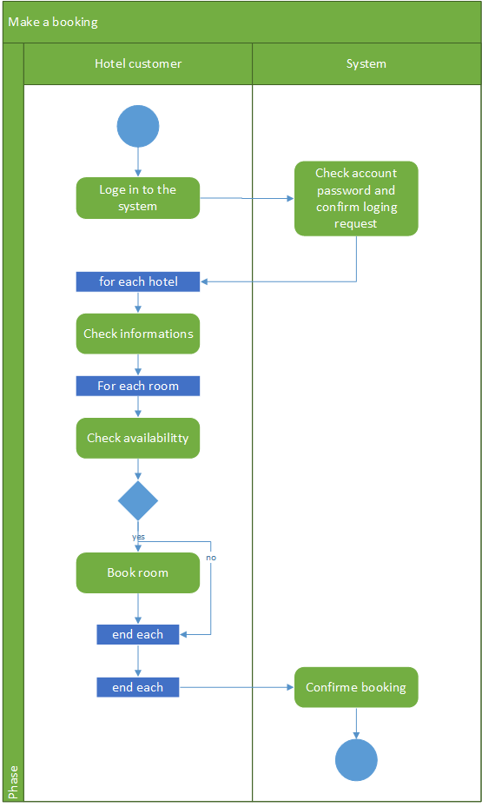
Hotel, customer, rooms and booking are the class of the system. Hotel and customer associate with the customer reserve the hotel and rate the hotel. Each customer and hotel has booking and each Booking has rooms. Each hotel has rooms.

Fig. 4: Activity diagram for moke a booking
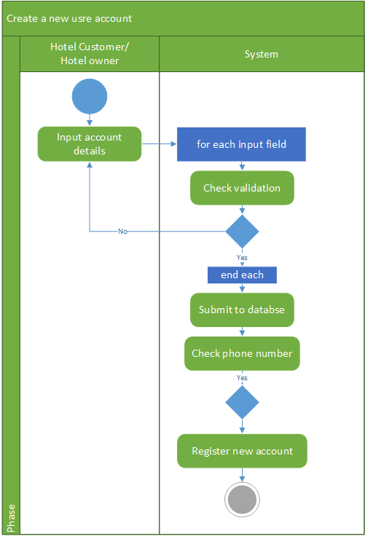
In booking activity first customer need to login to the account. Then customer check availabilities and details of each room add rooms into booking list. Final all the details are completed system confirm the booking.
Fig. 5: Activity diagram for create account

Register new account is one of main activity of “ReserveMe”. Activity flow of this is start with user fill input fields. Before submit data to submit data base system check the validations of fields. If all the fields are correct then system submit account details into server. Then if there is no existing account in database for that phone number create the new account.
ER diagram for the “ReserveMe” is shown in Fig. 6. Since this system need a real time database. Database of the “ReserveMe” has created in the “000webhost” online sever There are five tables in the data base as hotel, customer, booking, room and booked room. In this system both kind of users can create account and log in to it. The “customer” and “hotel” tables are store details of registered user of the system. ‘Room’ table stores data about the each room of a hotel. One hotel may have many rooms so there is a one to many relation between hotel and room. There should be separate entry for each and every booking. The “booking” table keeps details about reservations. Customer can make many booking one booking has one hotel and more rooms. So there is a one to many relation between booking and hotel, booking and customer. And also relationship between “room” and “booking” is many to many, So database schema use another table called “booked room” represent that relation.
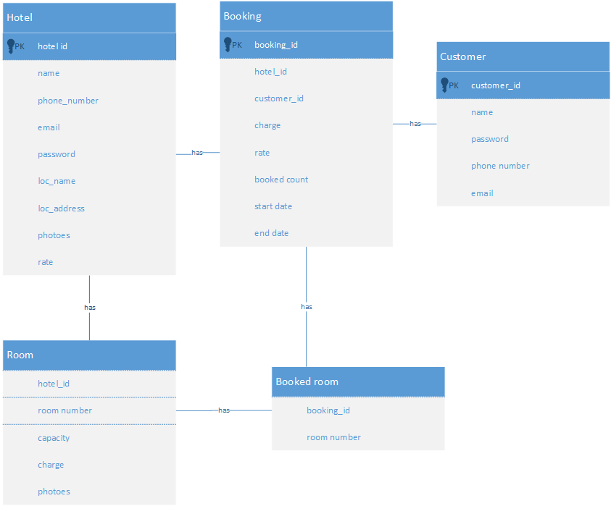
Fig. 6: ER diagram

system implementation

Implementation Procedure
Java was used as the programming language with Android Studio as the IDE for the Android platform. Android Virtual Device (AVD) was used to test every step of the system at first. And also used and android mobile phone with low performance with USB Debugging feature for test the system. When use the default AVD provided by the Android Studio work at the same time it makes computer very slow as it takes most of the memory. So used Genymotion android virtual devices used for test the system. After using those devices that problem didn’t occur much.
Accessing of online database happened through the php files. Phpstome used as the IDE for write php files. 000webhost used as the online sever it provide phpMyAdmin free and open source tool to handle the administration of MySQL. Data base schema was implemented using that tool.
Image icon for the application are created using Adobe Illustrator CS6. Some demo photos for hotels and rooms are free downloaded from internet. Android need images with deferent resolutions for show in deferent size of displays. Final Android Resizer (Executable Jar File) for convert images from extra high density pixel to extra low density pixel.
Android SDK version 22 was used as the compiled version and the target SDK version with enabling system to work on devices which have Android version 14 or above. Android version 14 was selected as the minimum SDK as it is the major version of Android in the market. Almost all of the devices which are in use have this version or an above one. So all the android devices in use can use “ReserveMe” without any problem.

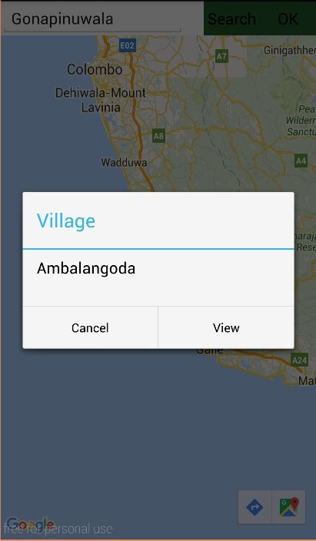
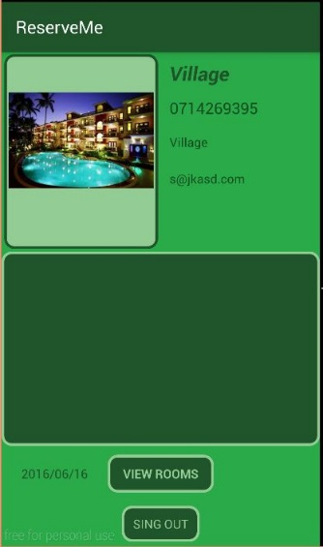
Main Interfaces
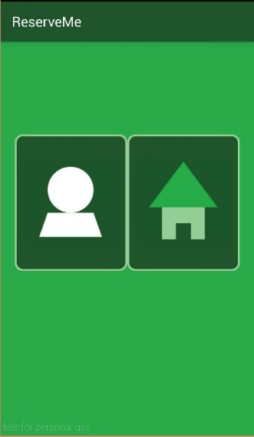
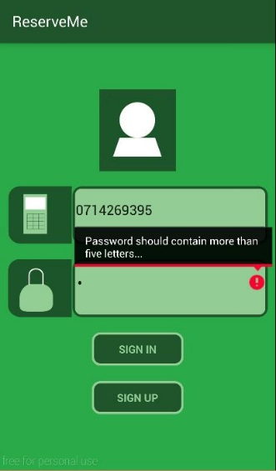
Interphase are design using XML. Most of time used flow layout for design them. Otherwise orientation of component may change with the device size. Image icon for the application are created using Adobe Illustrator CS6. Android need images with deferent resolutions for show in deferent size of displays. So add different size of images from same image. Login view, Loading view, View hotel profile, hotel main view, customer main view, search hotel and reserve hotel are the main interfaces of “ReserveMe”.
Fig. 7: Login UI Fig. 8: Loading UI
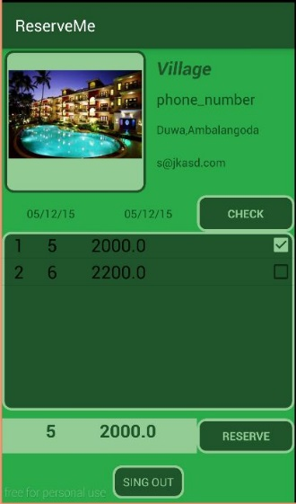
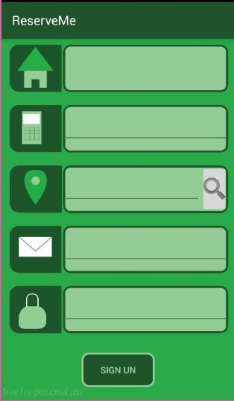
First users need to select the type of there account type from the loading window. Fig. 8. Shows that window. Then they can log in to system using username and password.
Fig. 9: Sign In UI Fig. 10: View Hotel UI

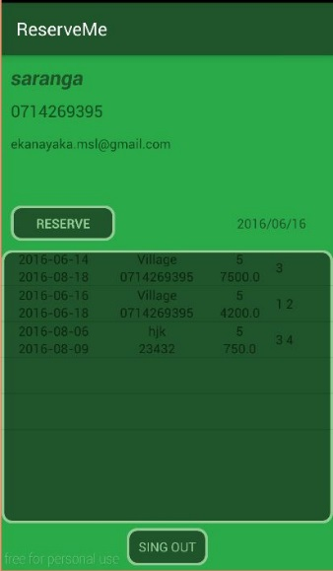
Fig. 11: Customer main UI Fig. 12: Search Hotel UI
Fig. 13: Reservation

system testing and analysing

Unit Testing, Results and analysis of testing
Testing of the ReserveMe is carried out under several categories. They are, Data and Database Integrity Testing, Function Testing, User Interface Testing, Performance Profiling, Load Testing, Security and Access Control Testing, Failover and Recovery Testing, Configuration Testing Those categories would comprise both manual and automated testing appropriately.

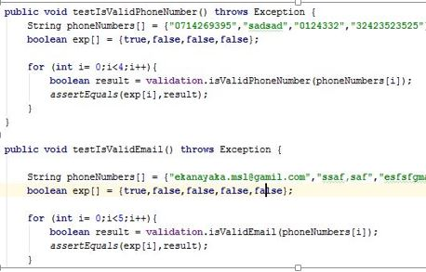
Unit test – junit:4.12, Unit testing can be done in the implementation process while developing the code and it was used to test functionalities module or class individually at completion of unit by the developer. The primary goal of unit testing is that taking the smallest piece of testable software in the application, isolating it from the rest of the code and determining whether that piece of code performs as expected.
Fig. 14: Sample test code

I have used an automated testing tool Appthwack.com which is available in the internet. It provides different types of automated tests which are run on devices in the cloud.

Fig. 15: Performance Testing
Fig. 16: Devices Based Testing

conclusion and future work

Conclusion
The system developed successfully such that all the main functional requirements were achieved.
I hope after launching this in Google Play App store “ReserveMe” may not be famous among travelers because fist system need some considerable amount of registered hotels for reservation so fist I hope to promote this through hotel. It may be a difficult task sine lack of technology knowledge of hotel owners. They may require some training for use this application.

Future Work
Currently users only can rate the hotels it is not sufficient. So I hope to introduce use feedback system for “ReserveMe”. Initially system data base is empty one so it may take some considerable time to fill. So I hope to extract some details like user comments, images of hotels shows in Google map.

References
- Google Maps API, https://developers.google.com/maps/
- Android tutorial, http://www.tutorialspoint.com/android/

